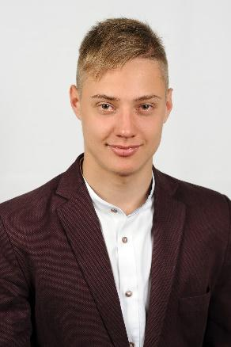

|  |  |  |  |
| --- | --- | --- | --- |
| **Contact information:**  Phone: +380991886005  Email: yaremakroma@gmail.com  GitHub: <https://github.com/RomariY> | | **Roman Yaremak** | |
|  | | | |
| **Summary of Qualifications** | When I was 17 y.o. I took part at “HackForLocals 2.0”, a hackathon, where I presented a program called “Government economy control”. The main purpose of this application is to control incoming and outgoing funds. That helps to avoid corruption and helps to make the country's economy stronger and increase the living level in the country.  Also, I’ve had a lot of experience in using “Photoshop” and “Lightroom” apps. That means that I have a pre-intermediate knowledge of the design industry.  Also, I’ve had my own projects which you can find in my GitHub account. | | |
|  | | | |
| **Skills** | Hard skills:  - Python  - C/C++  - HTML/CSS  - JS  - Bootstrap  Platforms:   * Windows (10, 7, XP) * Linux (Mint, Ubuntu, Kali)   Soft skills:   * Think critically * Easy to learn new * Supportive * Friendly * Determination | |  |
|  |  | | |
| **Experience / IT related educational practice** | Work  o GotYourBack  I’ve been working as a technical support representative for 3 months, where I remotely fixed different issues on the Windows operation system. After this, I’ve been working as a software support representative for 3 months. In the SS position, I’ve handled the support tickets with software-related issues, also as a SS representative from time to time I’ve spoken to clients. There were hard cases who took care of their own security and who rejected our offer to connect. So I’ve explained all of the steps via phone.  o BeautyProf  I’ve been working as an SEO representative.  My responsibilities include:   * moderating web page; * adding the goods in the admin console; * consulted with support manager about site proper condition; | | |
|  |  | | |
| **Languages** | Ukraine – fluent. | | |
| English – Upper-Intermediate (B2+) | | |
| Russian – Upper-Intermediate | | |
|  |  | | |
| **Education** | Physical technical lyceum 2017 – 2020 | | |
| IFNTUNG 2020 – present | | |
|
| **Additional education (courses, trainings)** | Photography and Photoshop courses 2016 – 2020  Udemy – Web developer bootcamp. | | |
|  | | | |
| **Hobbies** | In my free time, I prefer cycling, reading books and traveling by car. | |  |

**Certificates:**

